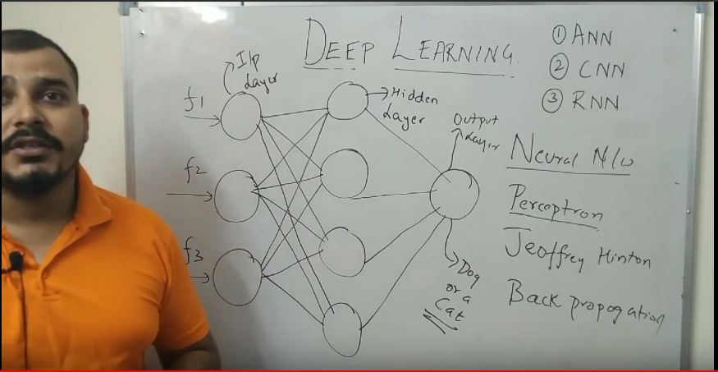

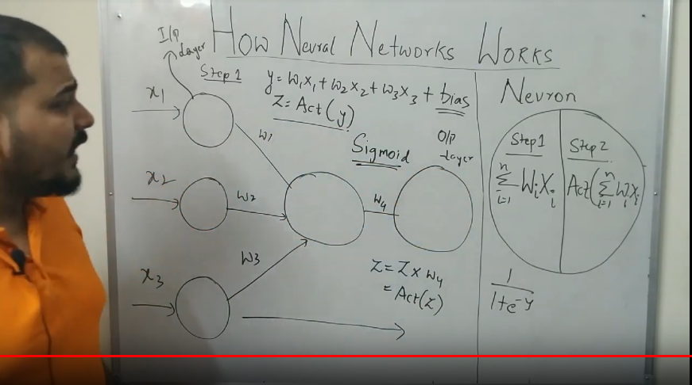

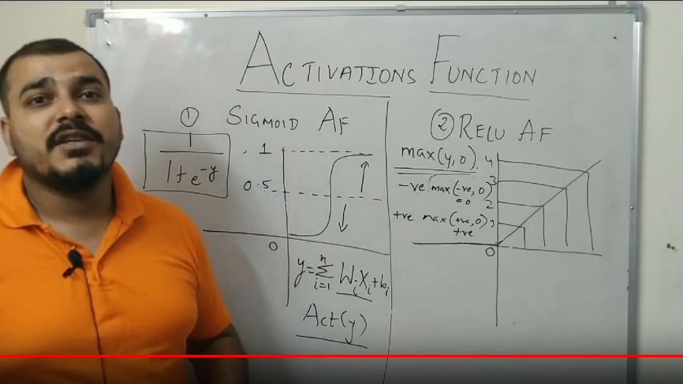

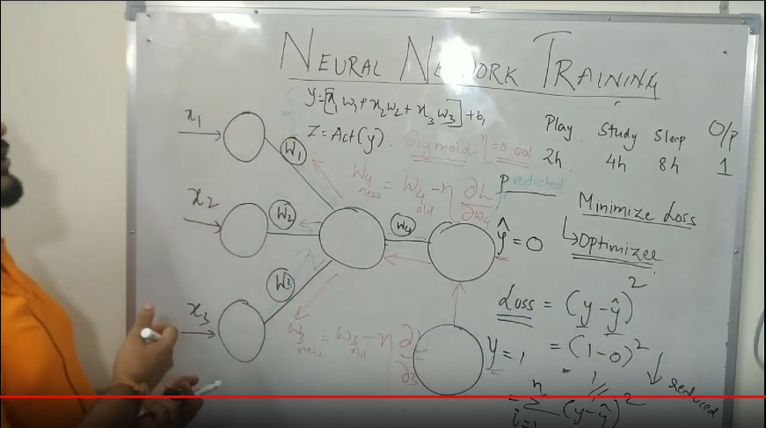

Tutorial 5- How to train MultiLayer Neural Network and Gradient Descent

<https://www.youtube.com/watch?v=cxPAvoIbsIk&list=PLZoTAELRMXVPGU70ZGsckrMdr0FteeRUi&index=5>

* Gradient Descent – It is optimiser used to update the weight in such a way that loss will get reduced to minimum and our Y-hat becomes equal to Y-Original.
  + Learning Rate – It should be as minimum as possible around (.001). So that it will reach bottom (global minima) slowly slowly. If we give high vlaue it will keep bounce inside curve and will never reach global minima. If we give too small value then it will reach to global minima but it will take too much time.
* Derivative means we are trying to find out the slope. Let’s assume our intial weight is where the tangent blue tangent line is(Left side). Now always look at the right side of tangent line, if it pointing down it means it is negative slope. If it is going up, it means it is positve slope. (In this case, it is pointing down, it means it has negative slope)
* Unless and untill we don’t reach global minima, updation of weight will keep on happening. (It means forward and backward propagation will keep on happening)
* One forward and one backward propagation ---- One Epoch.
* Let’s assume (incase of left side) my slope is negative. In W-new, - and negative slope will become positive. It means we are adding some weight to old weight. It means we are reaching to global minima. How slowly we are reaching to global minima it depends on learning rate.
  + Let’s assume (incase of right side) my slope is positve. In W-new, - and positve slope will become negative. It means we are substracting some weight to old weight. It means we are reaching to global minima. How slowly we are reaching to global minima it depends on learning rate.
* If loss value is not decreasing, it means it’s not reaching to global minima and it’s only bouncing here and there in curve.
* If Loss is not decreasing it means there is some problem with learning rate or gradient decent is not working. In this we can try some different gradient descent like, stochastic or batch gradiet descent.

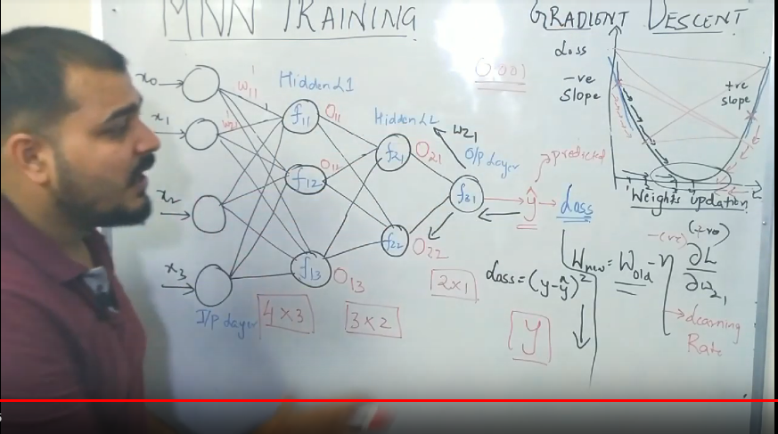

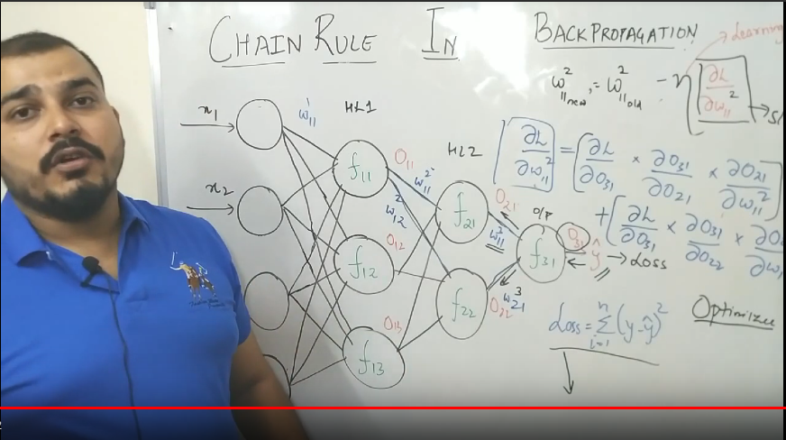

Tutorial 7- Vanishing Gradient Problem

<https://www.youtube.com/watch?v=JIWXbzRXk1I&list=PLZoTAELRMXVPGU70ZGsckrMdr0FteeRUi&index=7>

* Derivative of SIGMOID is always ranging between 0 to 0.25
* This video explains us how we should not have many hidden layers. If we have many hidden layers then due to sigmoid FUNCTION, new weight and old weight will become equal and it means…Gradient Decent optimizer is not working at all and ultimately Loss function is not BEING reduced.
* New weight and old weight is almost equal and it ill take huge time to reach global minima or say loss will not be reduced significantly. That is why Sigmoid can’t be used in every layer.
* Vanishing Gradient Descent problem was mainly because of Sigmoid. That is why ReLu comes in.

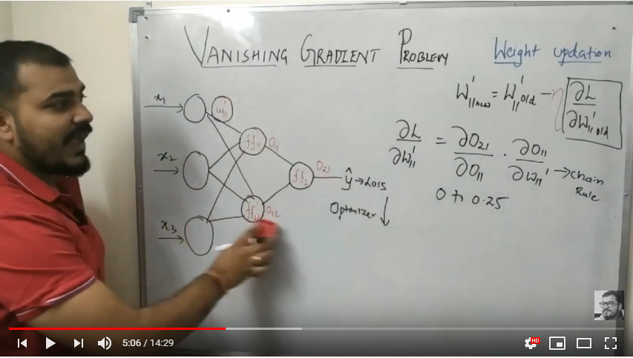

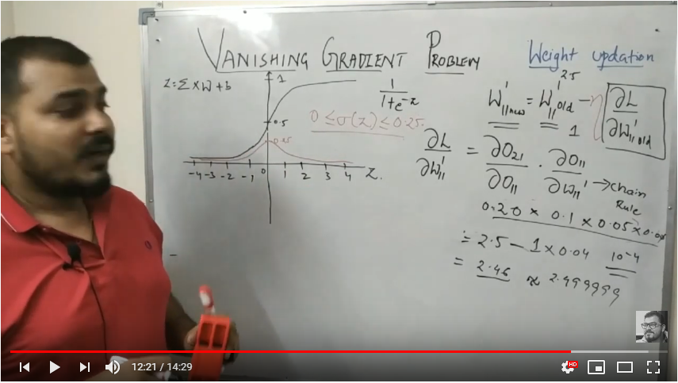

Tutorial 8- Exploding Gradient Problem in Neural Network

<https://www.youtube.com/watch?v=IJ9atfxFjOQ&list=PLZoTAELRMXVPGU70ZGsckrMdr0FteeRUi&index=8>

* Exploding Gradient Descent problem will only happen due high value of weights assigned. If we assign high weights, then there will be Exploding Gradient Decent problem. W-new and W-old varies a lot and will never reach global minima in gradient decent curve. (DOES NOT matter if you use Sigmoid or Relu). So we should initialize weight very carefully

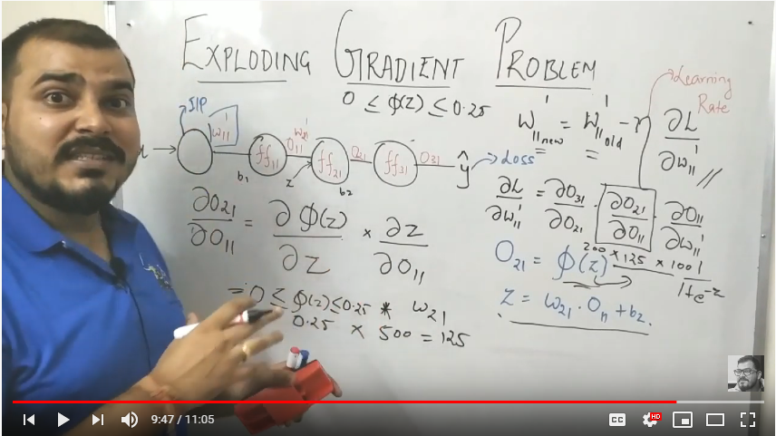

Tutorial 9- Drop Out Layers in Multi Neural Network

<https://www.youtube.com/watch?v=XmLYl17DbbA&list=PLZoTAELRMXVPGU70ZGsckrMdr0FteeRUi&index=9>

Dorp Out in Deep Learning is similar to Radom forest in Machine Learning. When we have very deep neural network then there will be many weights and bais parameters. These many parameters tends to overfit the data

* Drop Out is used to control Overfitting in Neural Network.
* Overfitting – It means neurons tries to fit the train data very perfectly. It leads to high variance and end up overfitting.
* Underfitting will never happen in deep neural network (Many layers). Undefitting will happen only when we have very less number of layers …let’s say 1
* Drop Out layer will be activating and deactivating the features and neurons
* Activation/Deactivation of features and neurons happens both in forward and backward propagation.
* First select Drop out Ratio (It’s range between 0 to 1, if we have too many hidden layers say very deep neural network in that case we should use greater than 0.5)
* Train Data- In this technique, we consider some features and some neurons(active neurons) in one iteration like we select some featres and some observation in random forest (Train Data)
* Test Data – Activation/Deactivation of features/neurons doesn’t happen in test data. Every feature and every neuron is connected in test data. Final weight which got fixed after training the data, we multiply those weight with drop out ratio in test data.
* To find best suitable P value, we can use hyperparameter optimization like cross validation

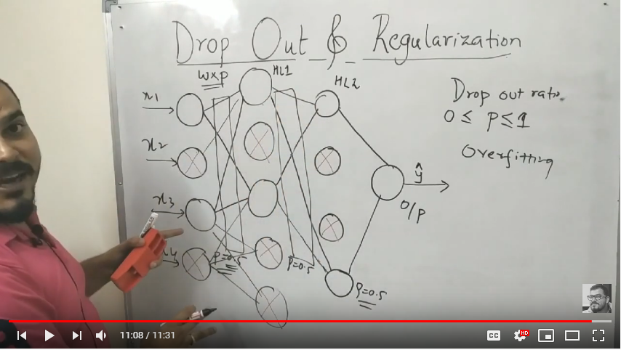

Tutorial 10- Rectified Linear Unit(relu) and Leaky Relu

<https://www.youtube.com/watch?v=DDBk3ZFNtJc&list=PLZoTAELRMXVPGU70ZGsckrMdr0FteeRUi&index=10>

Rectified Linear Unit

* It is an activation function used to over come vanishing Gradient decent problem
* Range of derivative of Sigmoid Actvation Function is 0 to 0.25 (Normal Sigmoid Range 0 to 1)
* Range of derivative of Threshold Actvation Function is 0 to 1 (Normal Threshold Range -1 to 1)
* Range of derivative of Relu Actvation Function is 0 or 1 (Normal Relu Range 0 to that positve number)

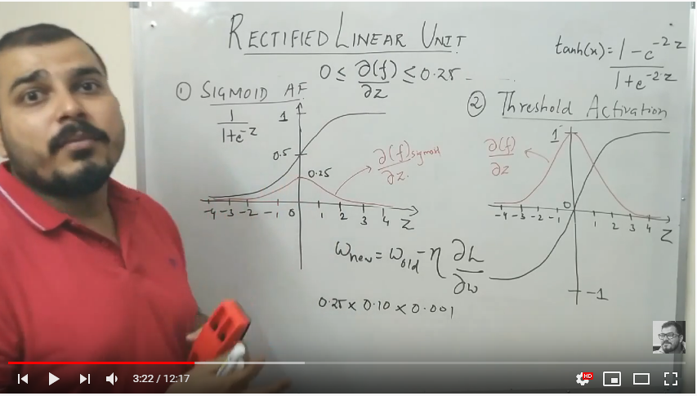

* While back propagation,
  + If value is positive then Relu will convert it into that positve value and we all know that derivative of tangent 45 (bcz point lies on this line) is always 1
  + If value is negative then Relu will convert it into 0. We can’t find derivative of 0. It means it remains 0.
* See in the below snapshot, While calculating new weight if derivative is 1 then no problem. But if it is 0 then after multipication all becomes 0 and it end up making dead neuron. This problem is solved using leaky Relu.

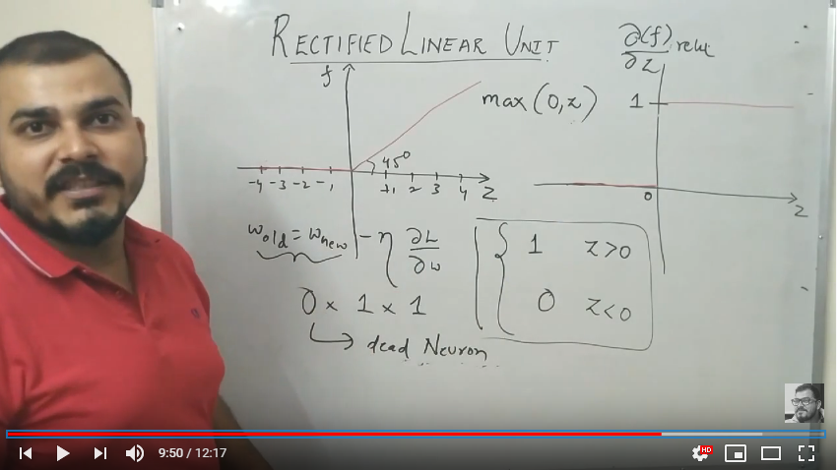

* Leaky Relu – It add some value to output like .01\*z. When we take the derivative of .01\*z. it will come as .01 not 0.

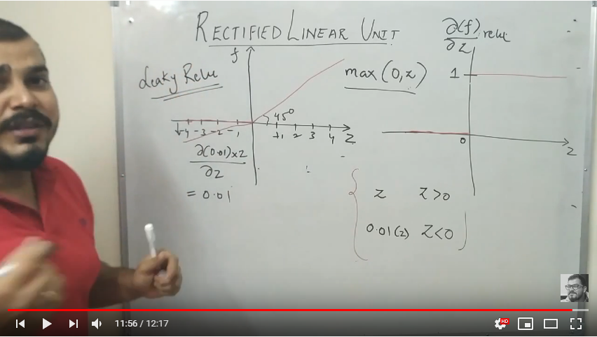

Tutorial 11- Various Weight Initialization Techniques in Neural Network

<https://www.youtube.com/watch?v=tMjdQLylyGI&list=PLZoTAELRMXVPGU70ZGsckrMdr0FteeRUi&index=11>

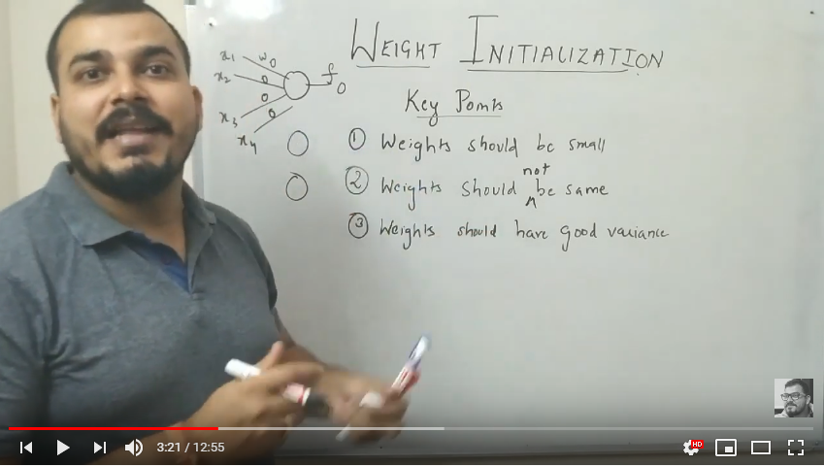

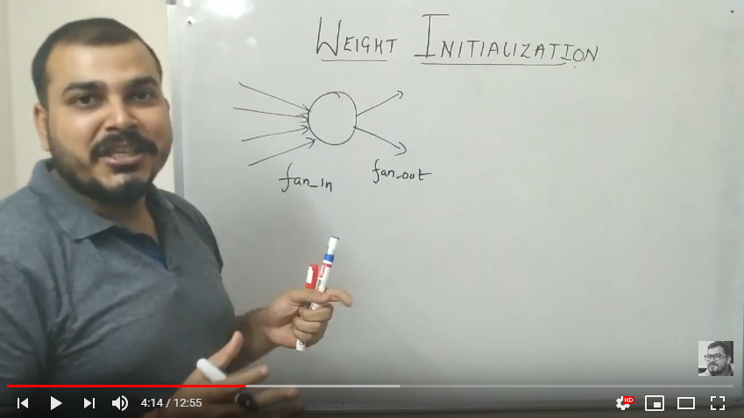

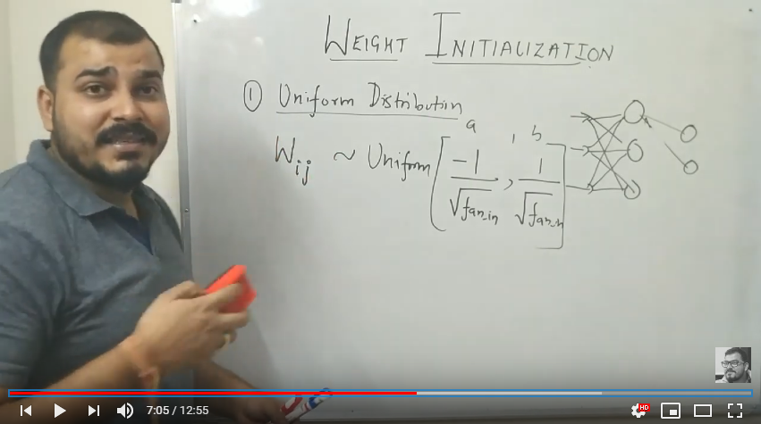

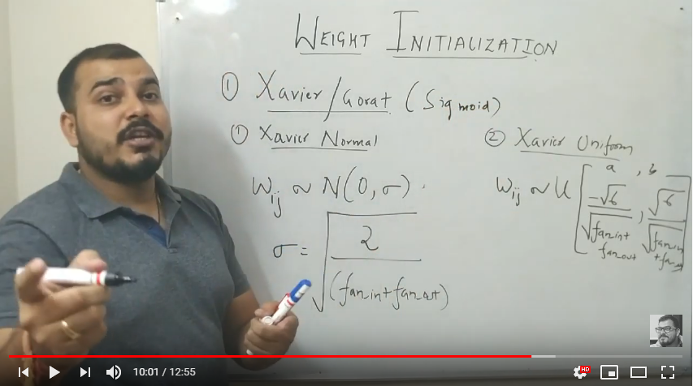

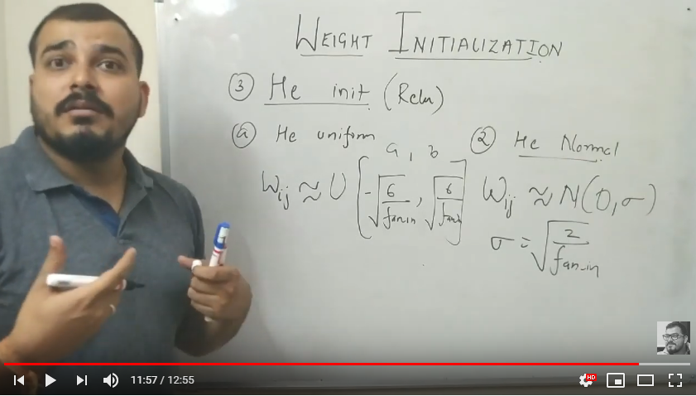

Tutorial 12- Stochastic Gradient Descent vs Gradient Descent <https://www.youtube.com/watch?v=FpDsDn-fBKA&list=PLZoTAELRMXVPGU70ZGsckrMdr0FteeRUi&index=12>

* Gradient Descent – It passes all records at a time to reduce loss function during backward propagation
* Stochastic Gradient Descent – It passes one record at a time to reduce loss function during backward propagation
* Batch Stochastic Gradient Descent - It passes one batch (let’s say 100 records in one batch) at a time to reduce loss function during backward propagation
* In ANN/CNN – Mostly we use Batch Stochastic Gradient Descent
* Gradient Decent – Generally we don’t use it because, if we have millions of records then GD will take huge amount of time in computation as it passes all records at a time similarly goes with stochastic (It will pass one by one and will take huge amount of time)

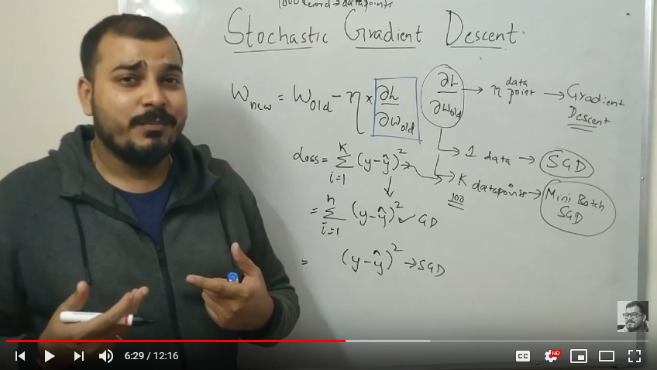

* Problems with Batch GD/SGD
  + GD/SGD use to convert weight, right if you remember. If we use GD, weight conversion will happen directly.
  + If we use Batch SGD then weight, conversion does not happen directly as shown in diagram. It follows zigzag pattern. New weight of batch SGD and new weight of GD/SGD will not be equal but approximately equal
  + This zigzag pattern is called as Noise. This will be handled by Stochastic GD with momentum

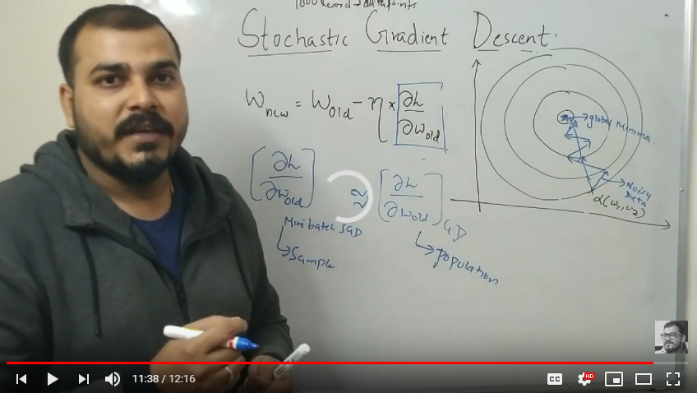

Tutorial 13- Global Minima and Local Minima in Depth Understanding

<https://www.youtube.com/watch?v=JLk0ee_zuOM&list=PLZoTAELRMXVPGU70ZGsckrMdr0FteeRUi&index=13>

* As shown in snapshot below (right side) – In this type of loss function GD is used to reduce/increase the weight and to find out the global minima where my final weight is. Here, you can see that there is no maxima as my curve can go upside up to any limit. So here, in this loss function there is no maxima and no local minima. There is only one minima i.e. Global minima
* There are some more loss functions which has maxima and local minima as well as with Global minima
* As shown in snapshot below (left side) – In this type of loss function, you can see that where is local and global minima.

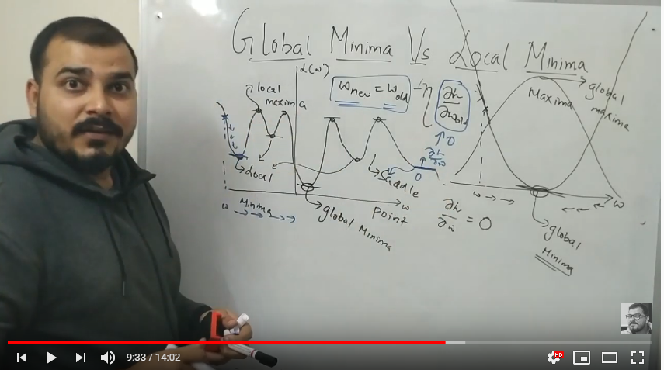

Below we are going to discuss two function convex function & Non Convex function

* Convex function always occurs in machine learning problems like linear & logistic regression. You will not find this in deep learning problems ( If we are connecting 2 points, while connecting if we find that points which are coming in between are also in same region. It means it is convex function.
* Non-Convex function occurs in most of the deep learning techniques. (If we are connecting 2 points, while connecting if we find that points, which are coming in between, are in different regions. It means it is Non-Convex function.

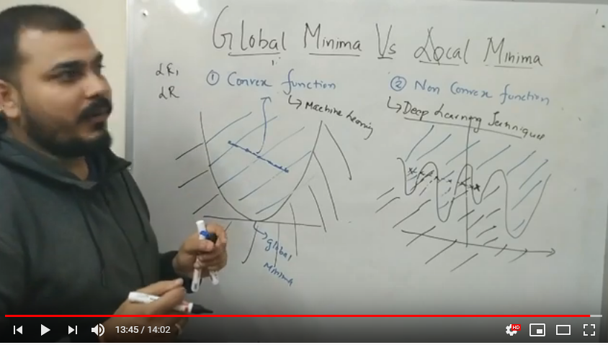

Tutorial 14- Stochastic Gradient Descent with Momentum

<https://www.youtube.com/watch?v=CKLwvuKWQjo&list=PLZoTAELRMXVPGU70ZGsckrMdr0FteeRUi&index=14>

* In left hand side diagram, you can see that the GD tries to reach global minima directly while SGD/Batch SGD follow zigzag pattern (Noise).
* In right hand side diagram, you can see the GD and SGD patterns in parabolic curve.
* Our intention is to remove is noise using exponential moving average. This method is called SGD with momentum. It remove the noise and you will see little bit straight line reaching towards global minima (2nd snapshot).

